899 Broad Street, Summersville, WV 26651

304-872-1148 [www.nlcawv.com](http://www.nlcawv.com)

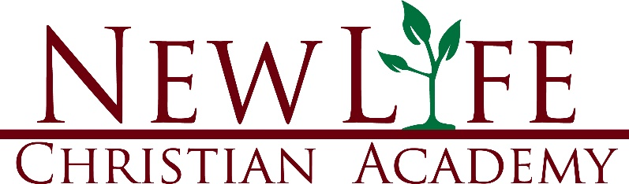

**Instructions to Pre-Pay Registration Fees for the following school year with leftover HOPE Funds:**

Log In

Go to Marketplace

Click on My School (or search for New Life Christian Academy)

Products and Services

Choose from one of the following options depending on your child’s grade:

Grades 1-12 Reg Fee for Next School Year $295 or Kindergarten Reg Fee for Next Year $175

Click Buy Now